EXP 27

clc;
clear;
close all;

% Processing Gain and PN Sequence Generation
% for Spread Spectrum Communication

% Step 1: Define Parameters
N = 7; % PN sequence length dataBits = [1 0 1 1 0 1 0];
Rb = 1000; % Data bit rate (bps)
Rc = 7000; % Chip rate (chips/sec)

% Step 2: Generate PN Sequence using 3-bit LFSR
% Feedback polynomial: x^3 + x + 1 register = [1 1 1];
PN = zeros(1,N);

for i = 1:N
PN(i) = register(3);

% XOR feedback

feedback = xor(register(3), register(1));

% Shift register
register = [feedback register(1:2)]; end

% Step 3: Display PN Sequence disp('Generated PN Sequence:'); disp(PN);

% Step 4: Calculate Processing Gain PG = Rc/Rb;
PG_dB = 10*log10(PG);

fprintf('\nData Rate = %d bps\n', Rb); fprintf('Chip Rate = %d chips/sec\n', Rc); fprintf('Processing Gain = %.2f\n', PG);
fprintf('Processing Gain in dB = %.2f dB\n', PG_dB);

% Step 5: Convert Data Bits and PN Bits to Bipolar Form dataBipolar = 2*dataBits - 1;
PNbipolar = 2*PN - 1;

% Step 6: Spread Data

spreadSignal = zeros(1,length(dataBits)*N);

for i = 1:length(dataBits) idx = (i-1)*N + (1:N);
spreadSignal(idx) = dataBipolar(i)*PNbipolar; end

% Step 7: Despread the Signal
recoveredBits = zeros(1,length(dataBits));

for i = 1:length(dataBits) idx = (i-1)*N + (1:N);

% Correlation with original PN sequence correlation = sum(spreadSignal(idx).*PNbipolar);

recoveredBits(i) = correlation > 0; end

% Step 8: Display Results disp('Original Data Bits:'); disp(dataBits);

disp('Spread Signal:');

disp(spreadSignal);

disp('Recovered Data Bits:'); disp(recoveredBits);

% Step 9: Plot PN Sequence figure;

subplot(3,1,1);
stairs(0:N-1,PN,'LineWidth',2); grid on;
ylim([-0.2 1.2]);
xlabel('Chip Index'); ylabel('PN Value');
title('Generated PN Sequence');

% Step 10: Plot Original Data subplot(3,1,2);
stairs(0:length(dataBits)-1,dataBits,'LineWidth',2); grid on;
ylim([-0.2 1.2]);
xlabel('Bit Index'); ylabel('Data');
title('Original Data Bits');

% Step 11: Plot Spread Signal subplot(3,1,3);
stairs(0:length(spreadSignal)-1,spreadSignal,'LineWidth',1.5); grid on;
ylim([-1.5 1.5]);
xlabel('Chip Index'); ylabel('Amplitude');
title('DSSS Spread Signal');

% Step 12: Verify Recovery
if isequal(dataBits,recoveredBits)
disp('SUCCESS: Original data recovered correctly.'); else
disp('ERROR: Data recovery failed.');

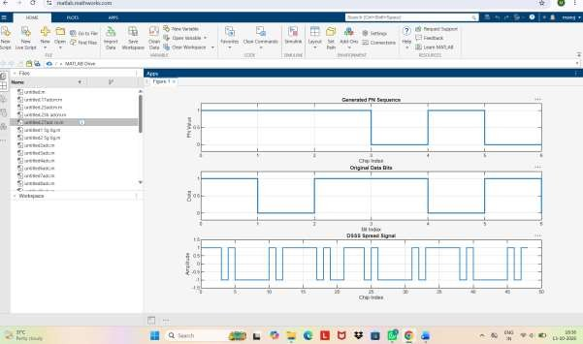
end

